# Type of software testing

## Verification (static-test)

* No execution of artifact is required to run during these tests (requirement specification reviews, design reviews, source code reviews, etc.)

## Validation (dynamic tests)

* Execution of artifact under test is required
* Divided into white box and black box tests later
  + White box – structural test
    - Test small parts of the software
    - Unit tests and integration tests
  + Black box
    - Execute binary machine code
    - Divided into functional and non-functional tests
    - Done both at system level and deployment (user acceptance) level
  + Regression tests are done for bot white box and black box tests

### Unit testing = testing business logic

* + Done after a class or component is constructed
    - Each class implements some business logic
    - Source code is checked to verify if the business logic is implemented properly
  + Done for extended testing when database access is involved
    - Business logic as well as database access aspect also need to be considered
    - Testing database connection and if database operation happens

### Integration testing = testing interfaces

* + Used to find out if a newly created class or components module can be integrated correctly with the rest of the software product
  + 3 main methods:
    1. Big bang – tries to integrate all modules or components of the system in one step
    2. Top-down – used when the top-level modules of the system are integrated and tested first
       - Internal parts of these modules are integrated with each other and subsequently tested
    3. Bottom-up – commonly used when the continuous integration method is used for software development

### Continuous integration

* + Used on agile projects
  + 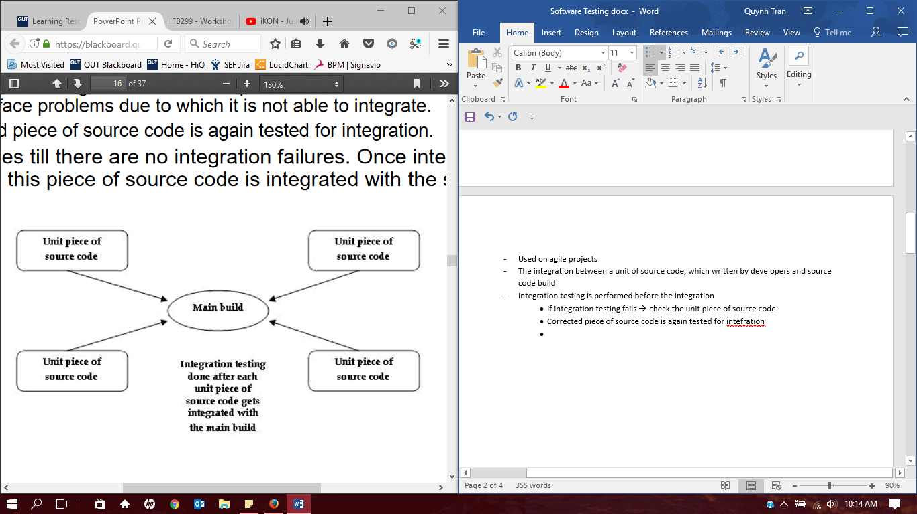The integration between a unit of source code, which written by developers and source code build
  + Integration testing is performed before the integration
    - If integration testing fails 🡪 check the unit piece of source code
    - Corrected piece of source code is again tested for integration
  + Once integration test passes (no integration failures), the piece of source code is integrated with the source code build

### Frequency of integration

* + Waterfall project 🡪 software products are developed first and integrated with each other later
  + Agile project 🡪 source code is continuously integrated

### System and user acceptance test

### Regression testing

* + To check if existing functionality of a software product features still work after integration of increment of software product features

### Alpha-Beta testing cycle

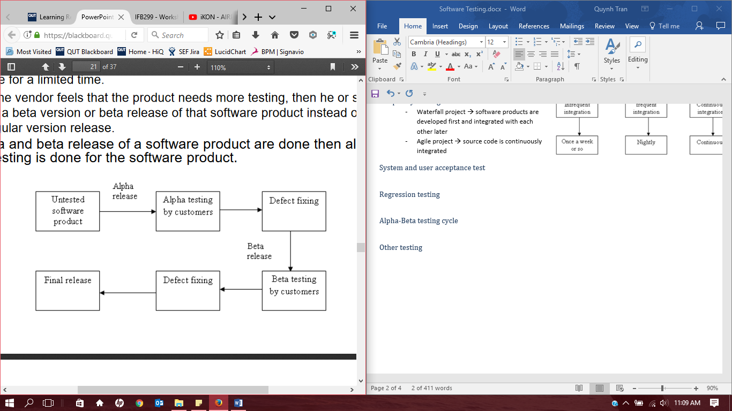

### Other testing

## Barry Boehm’s V model

* Requirement specifications – used to perform user acceptance testing
* Software design specifications – used to perform system testing
* Software module or sub system – used to perform integration testing